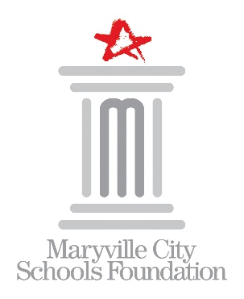

MARYVILLE CITY SCHOOLS FOUNDATION

2025-2026 Board of Directors Nomination Form

Mission: *to support the ongoing enrichment of educational programs for all students in Maryville City Schools*

Deadline: March 25, 2025

Thank you for your interest in nominating an individual for consideration for election to the Maryville City Schools Foundation Board of Directors. MCSF is a 501(c)(3) organization governed by its Board of Directors. Members of the Board are elected to serve a term of four (4) years. Your nomination will be considered for any Board seats becoming vacant in the 2025-2026 fiscal year.

Nominator Name: Click or tap here to enter text.

# Phone: Click or tap here to enter text.

Email: Click or tap here to enter text.

**NOMINEE INFORMATION:**

Name: Click or tap here to enter text.

# Address: Click or tap here to enter text.

City: Click or tap here to enter text. State: Click or tap here to enter text. Zip Code: Click or tap here to enter text.

Work: Click or tap here to enter text. Mobile: Click or tap here to enter text.

Email: Click or tap here to enter text.

Occupation/Employer: Click or tap here to enter text.

MHS Alumnus: Yes No Year: Click or tap here to enter text.

Check all schools where Nominee will have children attending during the 2025-2026 academic year.

FHE JSE SHE CGIS MRIS MJHS MHS MVS

Skills: (check all that apply)

Communications/PR  Legal

Estate Planning/Planned Giving  Marketing

Event Planning  Organizational Development

Financial Management  Organizational Governance

Fundraising  Strategic Planning

Human Resource/Personnel  Web Design

Additional community involvement:

Click or tap here to enter text.

Please give a brief statement of support explaining why you think this person would make a great addition to our board.

Click or tap here to enter text.

*Submit nomination form to:*

Mandi Wolfe

402 Melrose Street

Maryville, TN 37803

865-982-7121

mandi.wolfe@maryville-schools.org